SECTION | Supporter Liaison Officer / Disability Liaison Officer
POLICY / PROCEDURE | Lincoln City FC Access Statement
DATE OF ISSUE | November 2023
DATE OF REVIEW | November 2024
VERSION | 3

Lincoln City Access Statement (2023/24 Season)

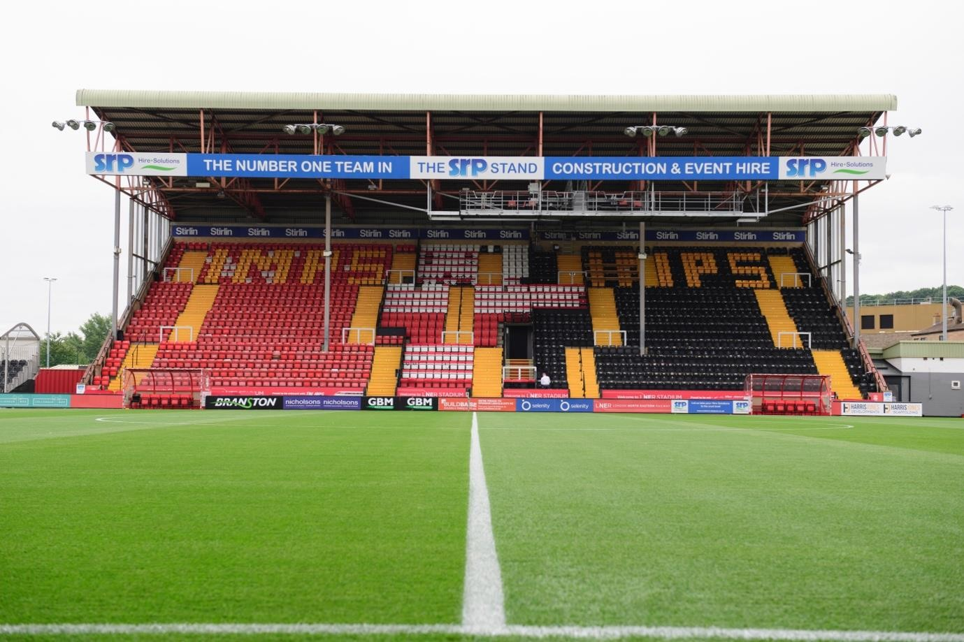

Introduction
Welcome to LNER Stadium’s Access Statement which has been produced by the club disability liaison officer, supporter liaison officer and the communications department to help you plan your journey to and from the ground. This document also provides information about access, facilities, and services that we provide for disabled supporters and visitors to LNER Stadium.

Stadium Map:

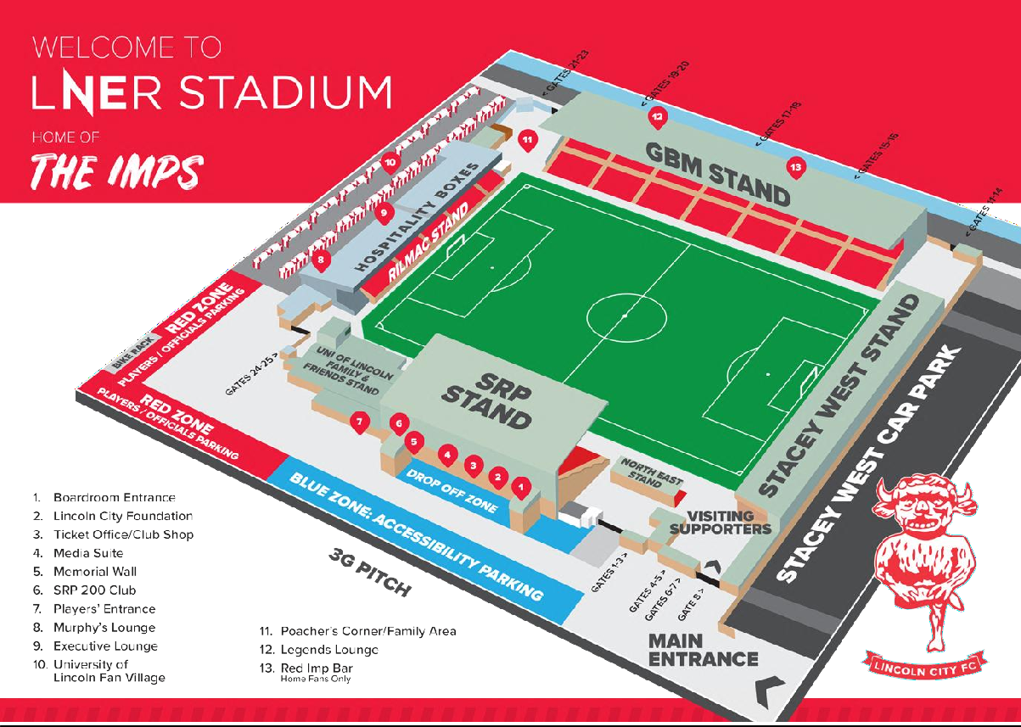

How to get to LNER Stadium:
(LN5 8LD) By Road:
From the North: via the A15 (Hull) or the A46 (Grimsby). - From the South via the A46 (Leicester, Nottingham, Newark) or the A1 and A15 (London, East Anglia) - From the East via the A158 (Skegness) - From the West via the A1 and A57 (Leeds, Worksop, Sheffield).

Parking:
We have limited parking available for disabled supporters which can be booked via email to tickets@theredimps.com ahead of the fixture. There is a drop-off point for cars and taxis near the main entrance located on Cross Street (see stadium map) with local car parks being a short 15-minute walk from the stadium. You can find out more about car parks at www.visitlincoln.com/carparks.

Official Coach Travel:
For any disabled supporters travelling aboard, official club travel will alight at the official drop off point for away coaches is on the south common (see map below). Please note, this drop of point is located approximately 0.8 km/ 0.5 miles (average 10-minute walk) from the stadium’s main entrance (sat nav postcode LN5 8ER). Should you require specific adjustments regarding getting to the Stadium, please contact us on tickets@theredimps.com

Rail/Taxi:
Lincoln Central Train Station is mainly serviced by LNER, EMR and Northern trains, and there is a taxi rank directly outside the station which features city cabs that are wheelchair accessible.
Lincoln Station | National Rail
Cycling
At the LNER stadium we have 15 bicycle bays which are available for the public to use. These do not need to be booked, but are available on a first come, first served basis. For information on cycle routes in Lincoln, please visit the link below:
Cycle Route Maps and Secure Bicycle Storage in Lincoln | Visit Lincoln
Whilst we do not have a designated accessible cycle park, please email our DLO if you have any questions regarding this.

Ticket Office Location:
The ticket office is at the back of the SRP stand next to the club shop which is directly opposite our 3G pitch between the two stairwells (see stadium map). - The ticket collection point is the ticket office, located within the club store. The ticket office has a lowered service counter suitable for wheelchair users. The ticket office and club shop are operated by a manual door.
For away supporters, tickets can be collected or purchased from the dedicated away ticket window located next to the main ticket office. Here, away supporters can also communicate any enquiries that they may have.
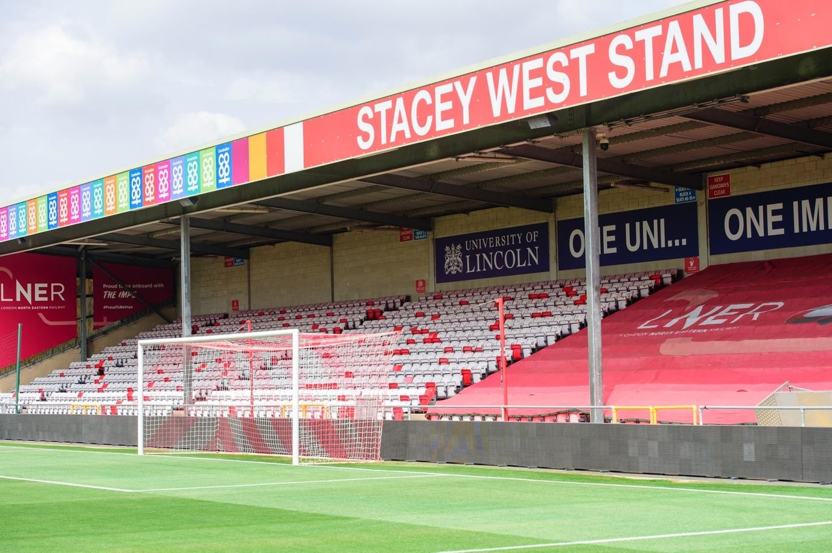
Turnstiles:
Away turnstiles are by the Stacey West Stand (see stadium map) and away supporters use turnstiles 4- 7. The stadium has wheelchair access via the large black gates adjacent to the turnstiles. Please see an SLO or steward who will be able to assist.

Wheelchair Accessible Toilet Facilities:
These are situated on the right-hand side as you enter the away end of the stadium and can be accessed using a radar key. A head steward DLO or SLO member will have a spare key if needed. All the wheelchair accessible toilets are unisex and the toilet doors all open outwards. The wash hand basins all have lever type mixer taps. The wheelchair accessible toilets are also fitted with appropriate height mirrors, hand dryers and coat hooks.
With the Stacey West stand currently undergoing building work until Summer 2024, away supporters have access to a temporary accessible toilet located next to the stand.

Generic Toilets:
There are both male and female toilets situated around the ground. Every standard toilet block contains cubicles suitable for ambulant disabled supporters.
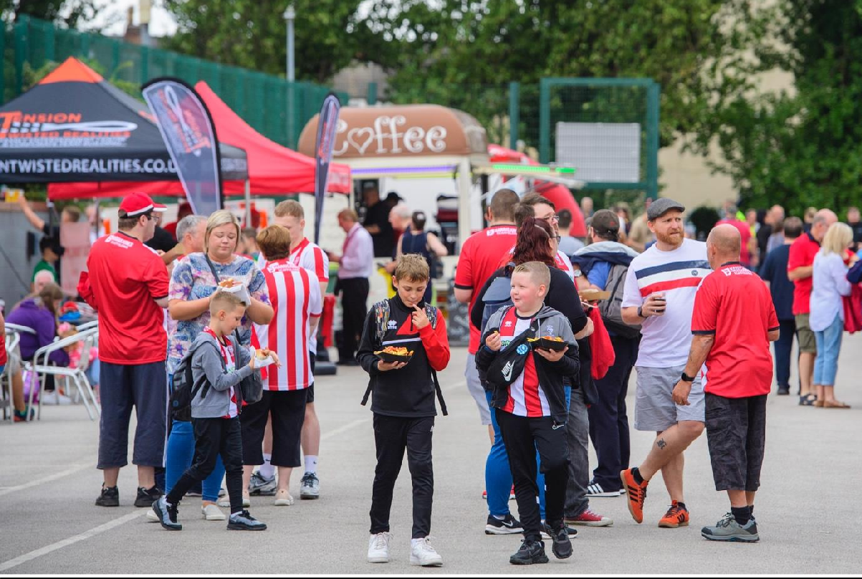
Catering:
Our University of Lincoln Fan Village is located behind the Rilmac Stand and is packed with great local food and entertainment ahead of our home fixtures. Additionally, we have catering available within the away end upon entering the stadium.
We have numerous bars around the ground that are accessible for all. The Centre Spot and Murph’s players' Lounge are located next to the University of Lincoln Fan Village and serve a variety of refreshments and snacks. There are also three hospitality areas at the club. The SRP 200 Club is situated in the SRP Stand and has an indoor bar area upstairs (this is accessible via a stair lift). Our newly refurbished Legends Lounge is situated within the GBM Stand. Legends Lounge seating is only accessible via stairs, however alternative seating can be provided in the lower tier if required.

Match Commentary:
We are proud to provide Audio Descriptive Commentary at the LNER stadium. Receivers can be obtained from our DLO/ticket office located within the club store between 1230-3 pm on a matchday. Although these can be borrowed with receivers on the day, supporters are encouraged to bring their own headphones, with a standard auxiliary jack. Further information or pre booking of ADC receivers can be obtained by contacting dlo@theredimps.com

BBC Radio Lincolnshire commentate on all Lincoln City games which can be accessed with a portable DAB/FM Radio. The radio station is on DAB or can be found on 94.9FM (104.7 medium wave).

Supporter Liaison Officers:
We have a team of dedicated supporter liaison officers (SLO’s) who are around the ground on a match day to assist you if required.

Disability Liaison Officer:
Heidi Langham is our dedicated disabled liaison officer; she can be contacted via e-mail dlo@theredimps.com if you have any issues or questions regarding accessibility in and around our stadium.

Safe Text:
We encourage any supporters to contact the ‘Safe Text’ line on 07384271937 to anonymously share information were they to experience any issues around safety or inappropriate behaviour, in or around the stadium.
Other Ways to Report:
Email feedback@theredimps.com
Telephone 079088 29499 or mmur@theredimps.com (Matthew Murgett – Head of Governance and Compliance)
Contact Kick it Out (0800 169 9414) or the Football Association (0800 085 0508)
Submit a report via the free Kick it Out app on a smartphone.

